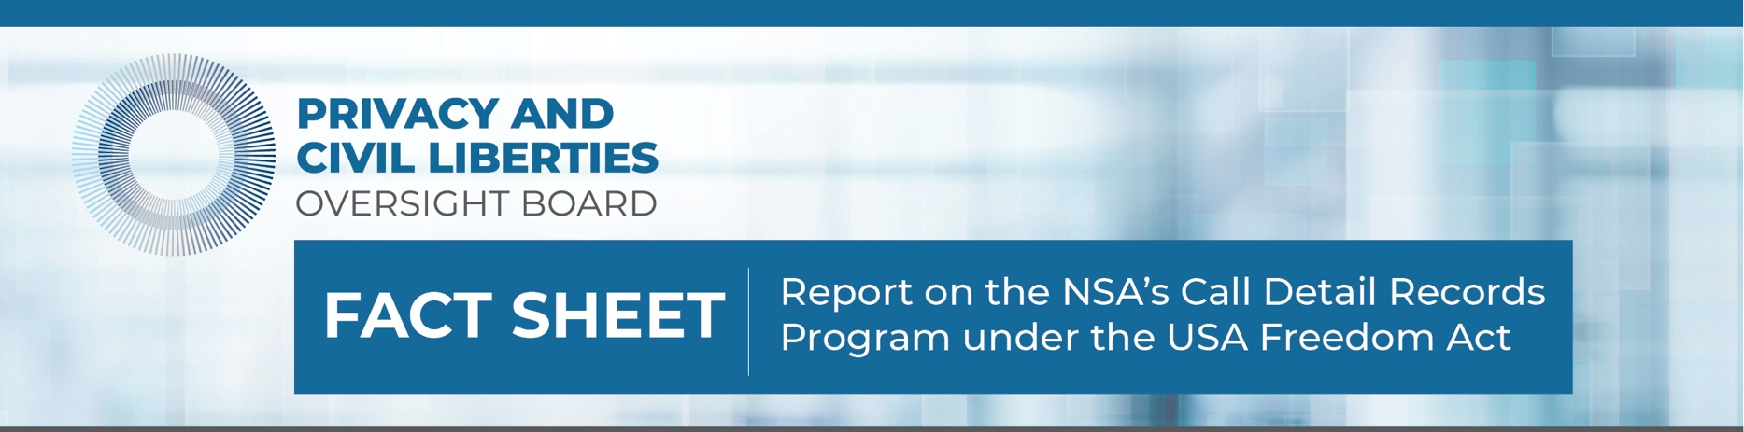

Follow us on Twitter: PCLOB_Gov

*Background*

The Privacy and Civil Liberties Oversight Board (Board) has issued its oversight report on the government’s operation of the call detail records (CDR) program under the USA Freedom Act. The NSA suspended its use of this program in early 2019 “after balancing the program’s relative intelligence value, associated costs, and compliance and data-integrity concerns caused by the unique complexities of using these provider-generated business records for intelligence purposes.” After suspending the program, NSA ultimately deleted the CDRs collected under the Act, with the exception of data referenced in disseminated Intelligence reports or used for mission-management purposes.

The Board completed this comprehensive review to provide transparency and clarity for the public. The Board secured the declassification of several important, never previously disclosed facts about the program. This additional information should enhance the public’s understanding of the government’s implementation of the CDR program.

The Board also has issued an unclassified version of the report to the public and a classified version of this report to Congress to assist Members as they consider whether to extend the USA Freedom Act before the authority sunsets next month. The report provides a detailed understanding of the CDR program and the privacy and civil liberties risks associated with the program.

*What was the Intelligence Value of the CDR Program?*

Newly declassified facts are bolded:

* **NSA acquired landline and wireless phone call records under the USA Freedom Act. NSA used the CDR program in response to a terrorist attack or a known terrorist threat. For example, NSA produced intelligence reports that were derived in whole or in part from the CDR program in its analysis of the 2016 Pulse nightclub shooting in Florida, and the Ohio machete attack that same year.**
* The USA Freedom Act CDR program cost the government approximately **$100 million**. Under the program, NSA produced **15 intelligence reports**.
* **Of the 15 reports citing USA Freedom Act CDRs, the FBI received unique information from two of the intelligence reports.**

*What do we Know About the Compliance Issues NSA Faced?*

* The program experienced a series of compliance incidents and data-integrity programs that led NSA to issue about a dozen notices to the FISA court since 2016. The Board reviewed each of these notices.
* While the Board secured declassification of many facts related to compliance issues NSA faced, some of those facts remain classified. These classified facts have been transmitted to Congress.
* NSA took steps to remedy its compliance incidents, including notifying appropriate oversight entities, imposing additional limits on data requests, and deleting erroneously obtained data.
* Based on a review of the data, the Board determined that the compliance incidents were inadvertent, not willful.

*What are the Board's Key Findings?*

* The Board did not issue recommendations in this report. Board Members, however, wrote separately addressing the issues raised by the facts related to the implementation of this authority.
* The Board found that the CDR program was constitutional under settled Supreme Court precedent. The Board also found that NSA’s collection of two hops of CDR data on an ongoing basis was statutorily authorized.
* Based on their separate statements, Board Members concur with NSA’s decision last year to halt the collection of CDRs.
* The Board found no abuse of the program, nor did it find any instance in which government officials intentionally sought records that they knew were statutorily prohibited.
* The Board found no evidence that NSA received any of the statutorily prohibited categories of information, such as name, address, financial information, cell-site location, or global positioning system information from providers during the program’s operations.
* Chairman Klein wrote a separate statement containing his additional views. Board Members Felten and LeBlanc wrote a separate statement containing their additional views and disagreeing with the Board’s constitutional analysis. Board Members Bamzai and Nitze wrote a separate statement containing their additional views.